

Q1:

Software Requirements Specification

for

<Project>[Student must replace this line by the name of project in the exam paper] (0.1 point)
Version 1.0 approved
Prepared by
<author>[Student must replace <author> by your full name and studentID] (0.1 point)
<organization>[Student must replace this line by the name of the FU Campus you take the exam] (0.05 point)
<date created> [Student must replace this line by the date you take the exam] (0.05 point)

Q2:
<Student must replace this line, answer Q2 by drawing 1 context diagram that reflect this exam paper and copy and then paste the image of that context diagram here
Notes:
- Draw the correct syntax to describe the context diagram (0.2 point)
- Draw external entities (0.3 point)
- Draw the data flows described in this exam paper (0.7 points)
>

Q3:
Notes:
- Draw the correct syntax to describe the use case diagram (0.5 point)
- Draw actors and brief descriptions (1.0 point)
- Draw use cases and brief descriptions (2.0 points)
<Student must replace this line, answer Q3 by drawing 1 use case diagram that reflect this exam paper and copy and then paste the image of that use case diagram here>
< Student must replace this line, briefly describe the actors of the diagram by fill the content to below table>
# | Actor | Description
01
02
03

< Student must replace this line, briefly describe the use cases of the diagram by fill the content to below table>
# | Use Case | Actors | Description
UC-01
UC-02
UC-03

Q4: <Answer of Q4 by fill the content to below table that reflect this exam paper>
UC ID and Name: | (0.1 point) the UC – 1 and the use case name here.
Created By: | (0.1 point) The name of your email account. | Date Created: | (0.1 point) The date you take the exam.
Primary Actor: | (0.1 point) the name of the actor that initiate use this use case. | Secondary Actors: | (0.1 point) The name of actor that use the data of the primary actor.
Trigger: | (0.3 point) the events that occur and then this use case will run.
Description: | (0.1 point)
Preconditions: | - … (0.2 point) The preconditions that must be true or must be done before this use case can run.  - …
Postconditions: | - …. (0.2 point) Describe the things must be done after the actors interact with this use case.  - ….
Normal Flow: | - …….(0.5 point) Describe the sequence of steps in normal case that must be performed by the actors or the system responses.  - …….  - …….  - …….  - ……
Alternative Flows: | - …. (0.3 point) Describe the sequence of steps in different case that can be performed by the actors or the system responses.  - ….  - ….  - ….  - ….
Exceptions: | - …..(0.3 point) Describe the sequence of steps that can be handle or implement when there are any exceptions.  - …  - …
Priority: | (0.1 point) Priority will help better plan when implement.
Frequency of Use: | (0.1 point) The more frequency of use, the more important.
Business Rules: | (0.2 point) All things in software related to data. The business rules should be specific so that can be design and coding.
Other Information: | (0.1 point) may be describe the quality here for more info.
Assumptions: | (0.1 point) The assumptions about the data related to this use case.

UC ID and Name: | The UC-79 – Book an ADN Examination Service
Created By: | namndse183115@fpt.edu.vn | Date Created: | Nov-19, 2025
Primary Actor: | Customer | Secondary Actors: | Staff, Payment Gateway
Trigger: | The user indicates the desire to book a DNA examination service
Description: | Guest/Customer can book a DNA test service by choosing:  - Self-collection at home  - Staff-collection at home  - On-site collection at the facility  Registered users may log in to prefill their profile; guest can proceed without login by login by providing required details.
Preconditions: | 1. User is on the DNA Testing service page
Postconditions: | 2. A booking record exists with the status “confirmed” or “pending”  3. If payment is not completed within define time, booking is auto-canceled  4. Notification is sent to customer and staff
Normal Flow: | - …….(0.5 point) Describe the sequence of steps in normal case that must be performed by the actors or the system responses.  - …….  - …….  - …….  - ……
Alternative Flows: | - …. (0.3 point) Describe the sequence of steps in different case that can be performed by the actors or the system responses.  - ….  - ….  - ….  - ….
Exceptions: | - …..(0.3 point) Describe the sequence of steps that can be handle or implement when there are any exceptions.  - …  - …
Priority: | (0.1 point) Priority will help better plan when implement.
Frequency of Use: | (0.1 point) The more frequency of use, the more important.
Business Rules: | (0.2 point) All things in software related to data. The business rules should be specific so that can be design and coding.
Other Information: | (0.1 point) may be describe the quality here for more info.
Assumptions: | (0.1 point) The assumptions about the data related to this use case.

Q5:
< Student must replace this line
Notes:
- Draw the correct syntax to describe the conceptual ERD (0.5 point)
- Draw entities and brief descriptions (1.0 point)
- Draw relationships (0.5 points)
>
<Student must replace this line, answer Q5 by drawing 1 conceptual ERD that reflect this exam paper and copy and then paste the image of that conceptual ERD here >

< Student must replace this line, briefly describe the entities of the diagram by fill the content to below table>
# | Entity | Description
01
02
03

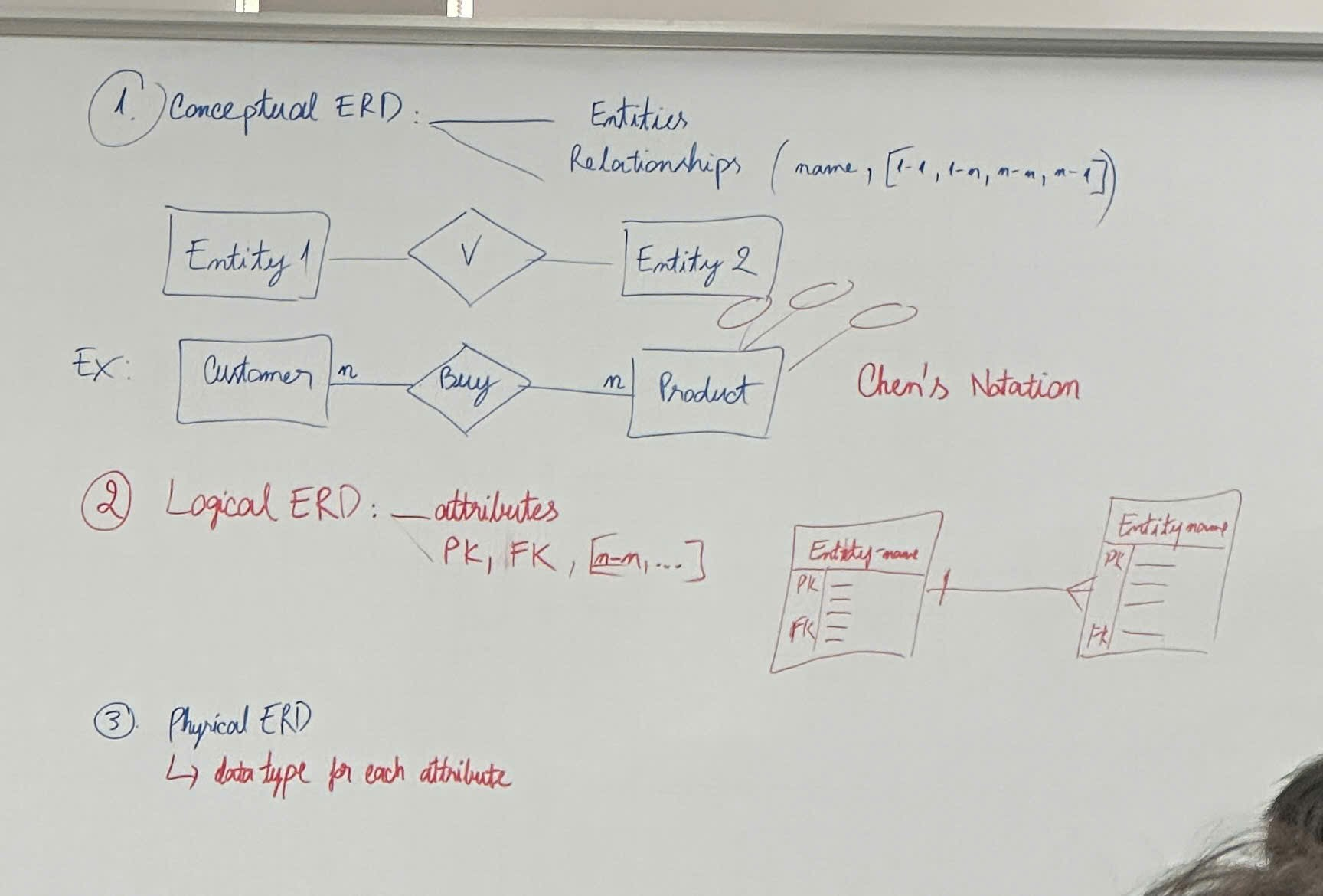
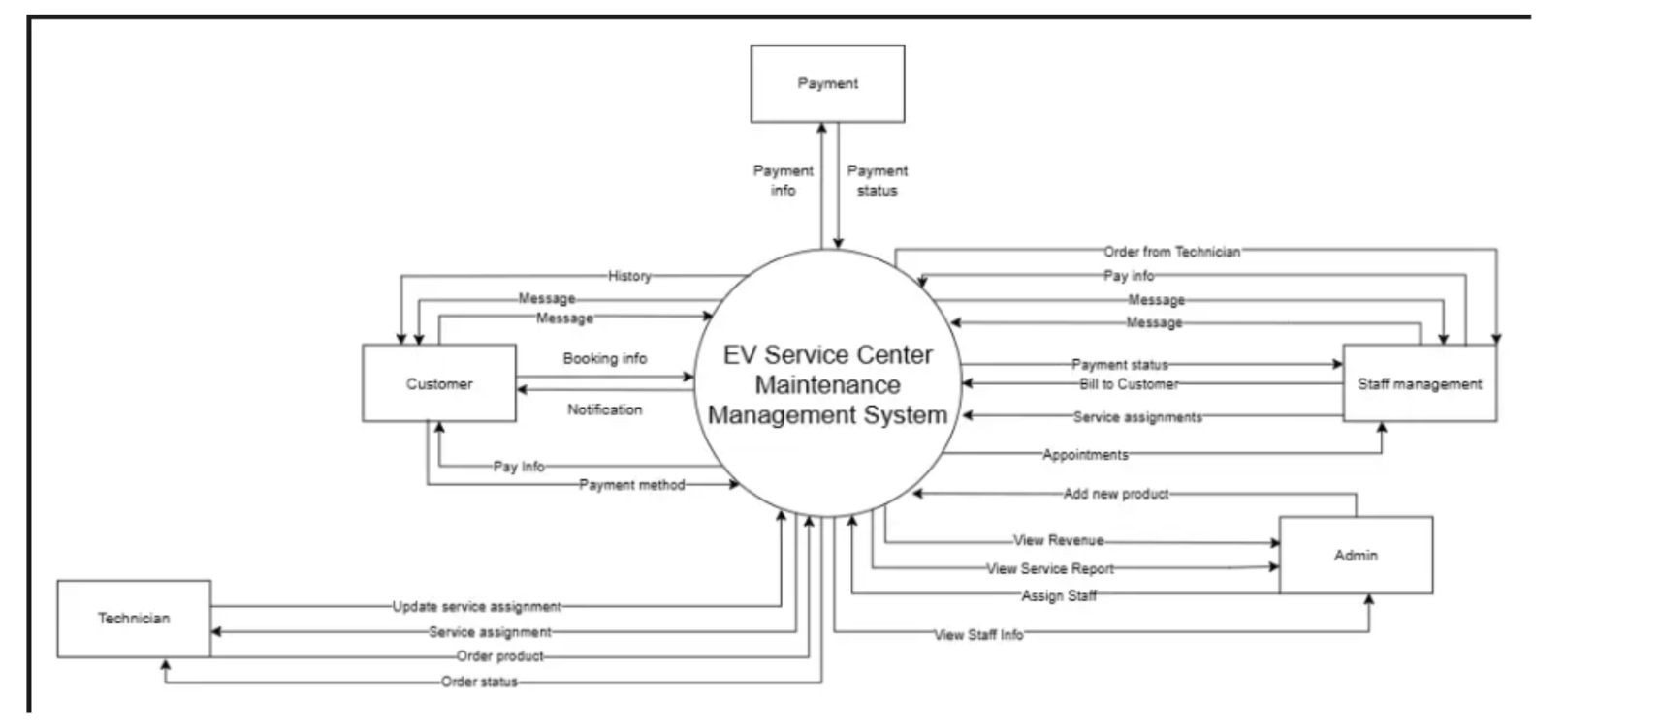
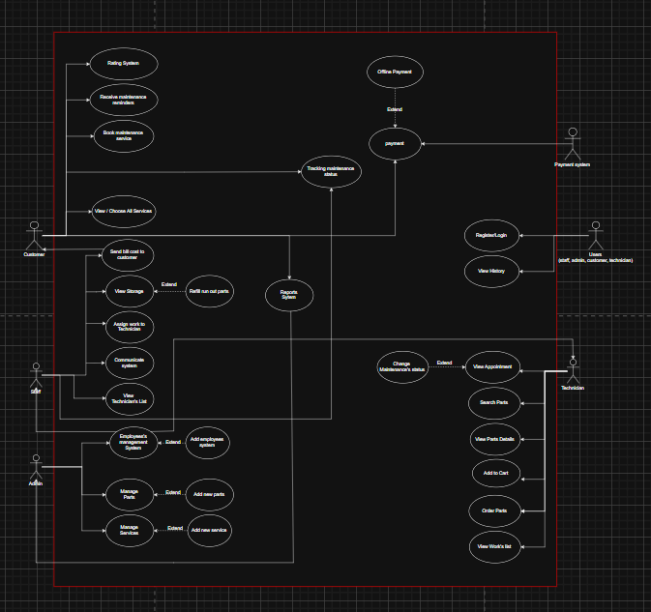
USE CASE-3 SPECIFICATION

Use-case No. | UC003 | Use-case Version | 1.0
Use-case Name | Maintain Vehicle
Author | Nguyen Duy Nam
Date | 02/11/2025 | Priority | High
Primary Actor: Technician
Secondary Actor: System database, Staff
Description:
This use case describes how a technician performs maintenance tasks for a customer’s vehicle. The technician receives maintenance requests, updates the progress, and records the results after completion.
Triggers:
A new maintenance request is assigned to the technician by the system or staff.
Preconditions:
- Technician is logged into the system.
- A maintenance task is available and assigned.
- Vehicle and maintenance details are recorded in the system.

Post Conditions:
- Maintenance task status is updated (Completed or Pending).
- Maintenance report is stored in the system database.

Main Success Scenario:
- System notifies the technician of a new maintenance task.
- Technician views the maintenance details.
- Technician performs the assigned maintenance work.
- Technician updates the maintenance progress in the system.
- Technician completes the task and submits a report.
- System updates the vehicle’s maintenance record and notifies the staff.

Alternative Scenario:
- Technician marks the task as “Incomplete” or “Needs Parts”.
- System notifies staff for support or rescheduling.

Exceptions:
- Network connection lost during update.
- Vehicle information missing or incorrect.
- Technician is not authorized for specific maintenance type.

Relationships:
Include: Generate Maintenance Report
Extends: Notify User About Maintenance Schedule
Business Rules:
<BR-12, BR-13, BR-16, BR-17, BR-18, BR-19, BR-31, BR-33>
